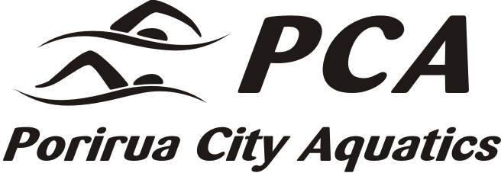 | HARDCORE MEET  LONG COURSE MEET  2nd November 2013  Wellington Regional Aquatic Centre  Kilbirnie  Warm up 5pm, Start 5.45pm


ORDER OF EVENTS  * Swimmers entering Ev 7 must be able to kick 50m in under 2minutes, Those entering Ev 8 must be able to kick 100m in under 3min. Kick races will be swum as mixed timed finals. Prizes will be presented to the fastest Boy & Girl in the following age groups 9/u, 10, 11, 12, 13, 14 15, 16, 17/Over (Age as at 2nd Nov)  Note; Swimmers must hold the board with both hands for the entire race, & may not use tumble turns in ev 8 or arm stroke/s at any time during the race, including into the turn or at the finish, in either kick race.  Door entry  - Spectators $2.00  - Programme $2.00  Swimmers & officials are to use their Swim Wellington passes. | MEET CONDITIONS  - Times are not required for events 7 & 8.  - Only one ‘No time’ entry per swimmer is permitted, this does not include or apply to event 7 or 8  - Times are required for those 11&U entering 400 free.  - The Organisers reserve the right to limit entries to allow the meet to finish within the allotted time frame. Should this be necessary entry fees will be refunded.  - Entries by c-file, with long course or converted long course times, accompanied entry report and fee summary, close on Tuesday 22nd October at race@swimpoirua.co.nz  - Entry fees: $2.00 for event 7 or 8. $8.00 per event for all other races. Entry fees & meet fee report are to be received by The PCA Treasurer, 32 Nelson Ave, Aotea, Porirua 5024 no later than 24th October. One cheque per club, or club’s may pay directly into PCA’s account no 030547 0205093 00. PCA is GST reg. No 55-174-466  - No refunds after the psych sheets are circulated.  - All participants must agree to comply with the Sports Anti-Doping Rules.  - Officials; 2 IOTs and 2 Timekeepers per club. Clubs with higher entries may be asked to provide more officials. Please advise names of officials to Terry Laws at terrylaws@xtra.co.nz  - Entry constitutes consent to photographs for publicity purposes.  - Porirua City Aquatics will not be liable for any loss, damage or injury that may occur at this meet  Meet Organisers: Viv Morton, 2347071 & Terry Laws 2330360
  M | F | Event
  1 | 2 | 400 freestyle
  3 | 4 | 50 Breaststroke
  5 | 6 | 200 Butterfly
  7* | Mixed 12 & U 50 kick
  8* | Mixed 13 & 0 100 kick
  9 | 10 | 200 Breaststroke
  11 | 12 | 50 Butterfly
  13 | 14 | 100 Backstroke
  15 | 16 | 50 Freestyle
  17 | 18 | 200 Medley
Swimmers who competed in at least three events will be eligible for one of the four cash prizes of $50.00 to be drawn at the conclusion of the meet.
Swimmers must be present at the draw to claim their prize.

